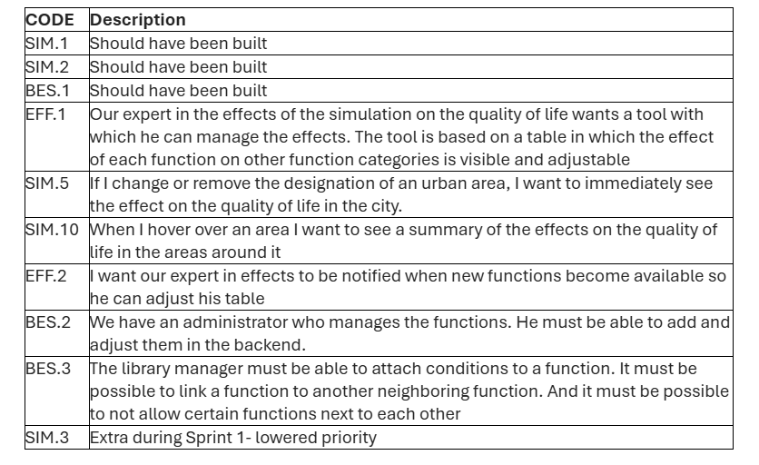
Klantinterview 2 – Notulen

14:30 – Start interview

Good to know – Anne took contact with expert in the effects about calculations.
Matrix is ready with texts for relevent rules after this interview.

Calculations:
- Anne wants an overview on the different functions.
- Score ranging from -5 to +5 on effect on for example safety,
- Safety, recreation, environment, facility etc. all categories combined becomes the quality of life score. QoL score should be a sum, not an avg.
- There are accompanying rules about some conditions. Some have combinations of certain functions having positive or negative effects.
Relation between Administrator and Expert of Effects
- An administrator should have full accessability to managing, editing functions, so adding, editing and deleting functions.
- If theres an adjusment to calculations an admin should be able to put it in the table.
- An admin should have communicated with the expert of effects, so the admin shouldnt be able to do something without the consent/notifications for a change.
- Theres always a check by the expert of effects.
- When an admin changes the name of a function, it should be unavailable until the calculation is aligned again.
- Notification through email, app as extra “safety measure”.
They could be the same person.

Visible effects for the adjacency effects, so not diagonally (Radius) only horizontally and vertically

Linking functions
- Linking certain functions should be a possibility
- Linking a station and a road for example, should be able to move as one withing the system.
- Multiple functions should be able to be combined and move at once.
- For accuracy, put effects after placing functions on grid
- 2 functions who cant be put next to eachother on the grid, shouldnt be able to be linked/combined.
- Possible select option, though could be more work.
- Linking in the library doesnt make sense, so room for other options.
- When a functions gets adjusted.

More rules on adjacency
- When an adjacancy rule is violated there should be a popup or notification about it so you get notified for violating the rule.
- There should be restrictions on performing an action if you violate a rule, so you should not be able to perform it.
- If you hover over actions, there should be a statement for example: “this function has a negative effect on…”
- Park, school, hospital have certain negative connections to other polluting functions like roads, factories etc. we need specified/conditioned relations.
- Specified rules should for example pop up after you click on a button
- There should be a quick review on what you’re doing, and possibilities for more detailed feedback.

We could possibly send visualisations via email to Anne on if we are imagining the correct view on certain subjects and if we are on the right line. But not too much, because it then becomes a review.

The most important aspects on this sprint are just the user stories. Further questions can be sent on email, this week.

15:05 – Eind interview

